1. **INTRODUCTION TO HOSPITAL**

**RAM SAGAR MISHRA 100 BED COMBINED HOSPITAL**

RSM 100 bed combined hospital is situated in Sadhamau, Bakshi Ka Talab, Lucknow. The hospital is well known foe it’s satisfactory facilities. The hospital has a reputated image in the medical line. The hospital has very hard working medical and non-medical staff who are highly professional and disciplined in their duties. It is authorized by government of India. The hospital has proper sanitation and cleanliness so that the patients do not come in contact of any type of disease.

The hospital and its staff follow very strict rules and regulation. The hospital has many types of clinical and technical facilities so the patients would not suffer from any problem. There are regular health checkups are also done for the staff of the hospital. The hospital also provides residential area for the hospital staff and other members.

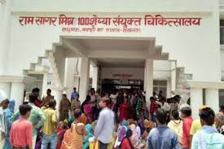

**Figure 1-** Ram Sagar Mishra 100 Bed Combined Hospital

1. **OBJECTIVES OF HOSPITAL TRAINING**
2. **Practical Exposure**: To immerse students in the hospital environment and provide real-world experience in patient care and hospital operations.
3. **Skill Development**: To build hands-on skills in clinical procedures, diagnostic techniques, and patient management.
4. **Teamwork and Collaboration**: To foster collaboration within multidisciplinary teams of doctors, nurses, and allied health professionals.
5. **Communication Skills**: To enhance both medical and interpersonal communication with patients, families, and healthcare staff.
6. **Patient-Centered Care**: To emphasize the importance of individualized care plans, focusing on patient needs, preferences, and satisfaction.
7. **Professional Ethics**: To teach students about maintaining confidentiality, integrity, and ethical standards in healthcare practice.
8. **Understanding Medical Technology**: To familiarize students with the latest medical technologies and equipment used in diagnostics, treatment, and patient monitoring.
9. **Time Management**: To cultivate the ability to prioritize tasks and manage time effectively in a fast-paced hospital environment.
10. **Critical Thinking and Problem-Solving**: To improve the ability to make informed decisions during medical procedures and emergencies.
11. **Adaptation to Hospital Culture**: To help students adjust to the work culture and hierarchy within hospitals.
12. **Medical Record Keeping**: To ensure accurate documentation of patient information, treatment plans, and outcomes in medical records.
13. **Crisis and Emergency Response**: To develop skills in responding to medical emergencies, including triage and urgent care situations.
14. **Patient Safety**: To focus on practices that prevent errors, infections, and ensure the overall safety of patients.
15. **Administrative Insight**: To provide a basic understanding of hospital administration, including scheduling, resource allocation, and patient flow management.
16. **Continuous Learning and Research**: To promote lifelong learning, staying updated with the latest medical research, and applying evidence-based practices in healthcare.
17. **About Hospital**

A hospital is a healthcare institution providing patient treatment, typically with specialized medical staff and equipment. Hospitals are key facilities in the healthcare system, offering a wide range of services, from emergency care to long-term treatment for various medical conditions.

1. **Healthcare Services:** Hospitals offer a variety of services including diagnosis, treatment, surgery, maternity care, emergency services, and rehabilitation. They serve patients with acute illnesses, chronic conditions, and those requiring specialized treatments.
2. **Medical Staff:** Hospitals employ doctors, surgeons, nurses, therapists, and other medical professionals. These staff members work in specialized departments like cardiology, neurology, orthopedics, oncology, pediatrics, and more.
3. **Departments and Specialties:** Hospitals are divided into departments based on medical specialties (e.g., radiology, intensive care unit (ICU), laboratory services, pharmacy, surgery, etc.), each designed to cater to specific types of healthcare needs.
4. **Facilities and Equipment:** Hospitals are equipped with advanced medical technology such as MRI machines, X-rays, ventilators, operating theaters, and ICUs.
5. **Types of Hospitals:**
   * **General Hospitals:** Offer a wide range of services to treat different conditions.
   * **Specialized Hospitals:** Focus on a particular field, such as children's hospitals, psychiatric hospitals, or cancer treatment centers.
   * **Teaching Hospitals:** Associated with medical schools, where medical students, interns, and residents receive training alongside providing patient care.
6. **Patient Care Levels:**
   * **Inpatient:** Patients stay in the hospital for overnight care or longer.
   * **Outpatient:** Patients visit the hospital for diagnosis or treatment and leave the same day.
   * **Emergency Services:** Hospitals provide immediate care for life-threatening conditions or injuries through emergency rooms (ERs).
7. **Administrative Functions:** Hospitals also have non-clinical staff involved in administration, finance, health information management, and patient services to ensure smooth operation and regulatory compliance.

**Role in Healthcare:**

Hospitals are integral to the healthcare delivery system, not only treating illness but also focusing on disease prevention, patient education, and public health promotion.

1. **HOSPITAL WARD**

* **First Aid**
* **Emergency**
* **OPD**
* **Pharmacy**
* **General Ward**
* **Injection Room**
* **Dressing**
  1. **First Aid**

First aid is the immediate assistance given to someone who is injured or suddenly taken ill. Its primary purpose is to preserve life, prevent the condition from worsening, and promote recovery. First aid can range from minor care, such as applying a bandage, to more critical interventions like CPR until professional medical help is available.

**Key Aims of First Aid (The Three P’s):**

1. **Preserve life**: The main goal is to save lives and minimize the threat of death.
2. **Prevent further harm**: This involves preventing the injury or illness from worsening, such as removing a person from danger or stopping severe bleeding.
3. **Promote recovery**: Encouraging healing, such as applying bandages or providing support until professional help arrives.

**Common Conditions Requiring First Aid:**

* **Hair tourniquet**: A condition where a hair or thread tightly wraps around a finger or toe, cutting off blood flow.
* **Heat syncope**: A condition related to heat stroke, where a person faints due to heat.
* **Heavy bleeding**: Treated by applying direct pressure to the wound and elevating the limb if possible.
* **Hyperglycemia (diabetic coma) & Hypoglycemia (insulin shock)**: Related to blood sugar imbalances.
* **Altitude sickness**: Can cause dangerous swelling of the brain or lungs at high altitudes.
* **Anaphylaxis**: A severe allergic reaction requiring immediate treatment, often with epinephrine.
* **Bone fractures**: Stabilized with splints until further care can be provided.
* **Burns**: Treated by cooling the burn and covering it to prevent infection.
* **Cardiac arrest**: Requires CPR and, if available, an Automated External Defibrillator (AED).
* **Choking**: Requires clearing the airway to restore breathing.

**Conditions that often require first aid**

• Anaphylaxis, a life-threatening condition in which the airway can become constricted and the patient may go into shock. The reaction can be caused by a systemic allergic reaction to allergens such as insect bites or peanuts. Anaphylaxis is initially treated with injection of epinephrine.

• Bone fracture, a break in a bone initially treated by stabilizing the fracture with a splint.

• Choking, blockage of the airway which can quickly result in death due to lack of oxygen if the patient's trachea is not cleared.

• Bums, which can result in damage to tissues and loss of body fluids through the burn site Cardiac Arrest, which will lead to death unless CPR preferably combined with an AED, There is often no time to wait for the emergency services to arrive

**Training:**

While many basic first aid practices, like applying bandages, can be learned through life experiences, professional training is crucial for life-saving interventions, such as CPR. Training is typically provided through certified courses, which are updated regularly as medical knowledge advances.

In emergencies, ambulance dispatchers can also provide first aid instructions over the phone.

By learning first aid, you can be prepared to act quickly and potentially save a life in critical situations.

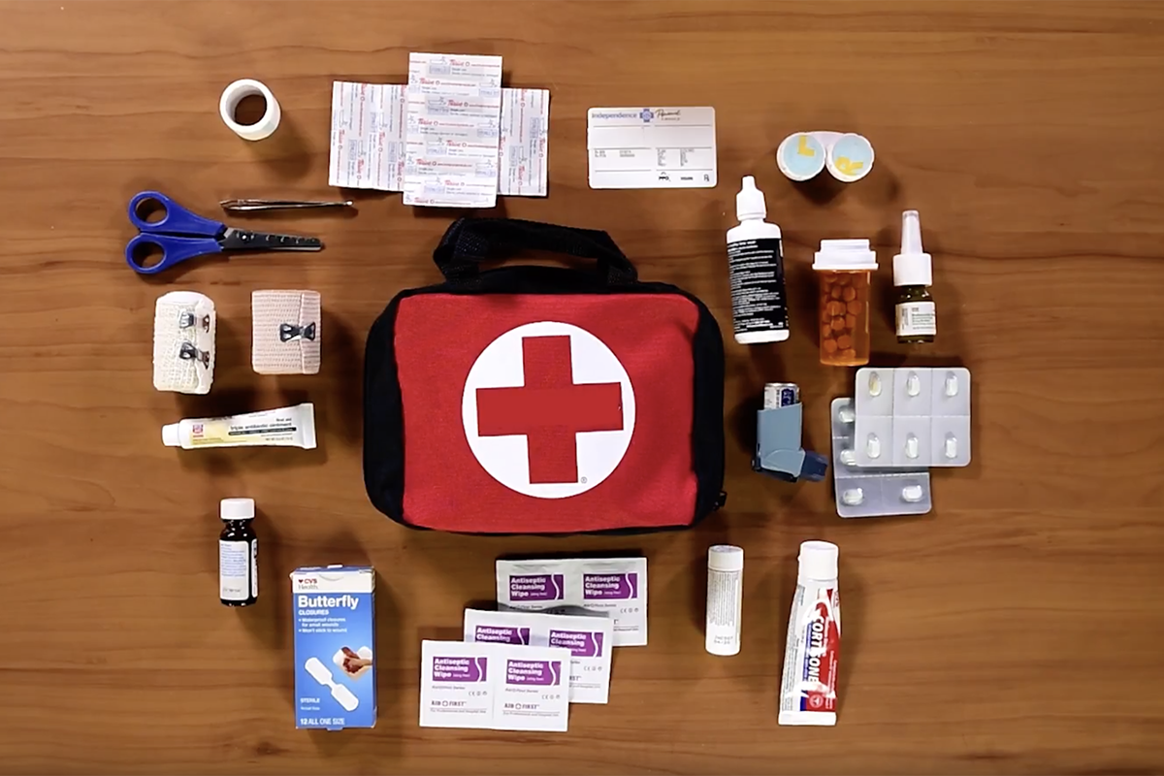

**Figure 2- First Aid**

* 1. **EMERGENCY WARD**
* An emergency ward is a dedicated area in a hospital that is organized and administered to provide a high standard of emergency care to people who are in need of, acute or urgent care including hospital admission.
* Emergency departments (ED) are an integral part of hospitals and medical practices and provide the best medical or surgical care to patients arriving in need of immediate care.
* EDs serve as the first point of contact, and people of nearly every age are given particular medical care based on their injury or illness.
* Emergency departments are well equipped with all the modern and essential equipment and accessories to render timely acute, emergency, trauma care services.
* A typical ED consists of nurses, doctors, and physicians who address a wide range of medical issues such as fatal injuries.
* The doctors in the emergency ward are very punctual to his work and treat patients in a very good manner.
* Emergency care 24 hours a day is provided.
* At least one experienced physician is always available in the ED to take the charges of emergency cases.



**Figure 3-** Emergency Ward

* 1. **OUT PATIENT DEPARTMENT (OPD)**

The Outpatient Department (OPD) is a part of a hospital or healthcare facility where patients receive care without being admitted to the hospital. It serves as a primary point for various healthcare services, offering convenience and accessibility to patients for consultations, diagnostics, treatments, and follow-up care.

1. **Consultations**: Patients can see specialists or general practitioners for various health concerns without the need for hospitalization.
2. **Diagnostic Services**: OPDs often provide basic diagnostic tests, such as blood tests, X-rays, and imaging services, to aid in the diagnosis of medical conditions.
3. **Treatment**: Minor treatments, such as wound dressing, injections, or administering medications, can be performed in the OPD setting.
4. **Follow-up Care**: OPDs are crucial for monitoring patients after treatment or surgery, allowing healthcare providers to assess recovery and adjust treatment plans as necessary.
5. **Health Education**: Patients often receive information and advice on managing their conditions, preventive care, and healthy lifestyle choices.

**Benefits of OPD:**

* **Convenience**: Patients can access healthcare services without the need for hospitalization, reducing costs and time away from daily activities.
* **Early Detection**: Regular visits can help in the early detection and management of health issues.
* **Continuity of Care**: OPDs facilitate ongoing monitoring and follow-up care, enhancing patient outcomes.

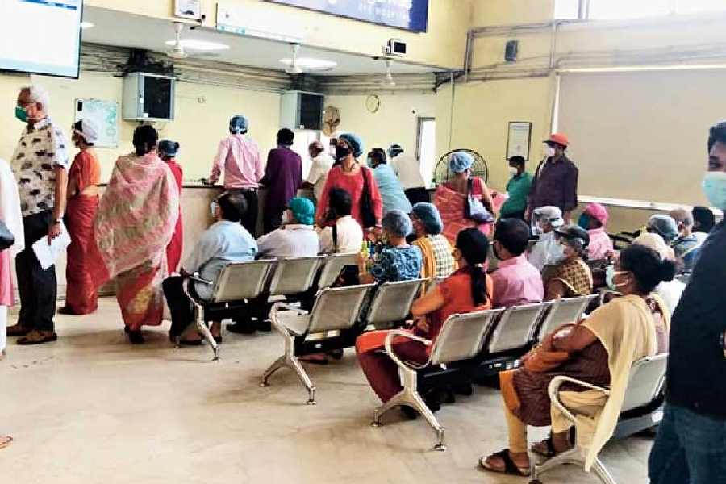

**Figure 4 -** OPD

* 1. **PHARMACY**

A pharmacy is a healthcare facility where medications are dispensed, and pharmaceutical care is provided to patients. It plays a crucial role in the healthcare system by ensuring the safe and effective use of medications, providing valuable health information, and supporting overall patient care.

1. **Dispensing Medications**: Pharmacies prepare and dispense prescription medications to patients based on healthcare providers' orders. They also provide over-the-counter (OTC) medications for various health issues.
2. **Medication Management**: Pharmacists review patients' medication regimens to ensure appropriateness, safety, and efficacy. This includes checking for potential drug interactions, allergies, and contraindications.
3. **Patient Education**: Pharmacists provide essential information about medications, including how to take them, potential side effects, and the importance of adherence to treatment plans.
4. **Health Screenings**: Many pharmacies offer health screening services, such as blood pressure monitoring, cholesterol checks, and diabetes management, to help identify potential health issues early.
5. **Immunizations**: Pharmacists are often trained to administer vaccines, providing an accessible option for patients to receive necessary immunizations.
6. **Consultation Services**: Patients can consult pharmacists for advice on medication-related issues, including over-the-counter medication selection and management of minor ailments.

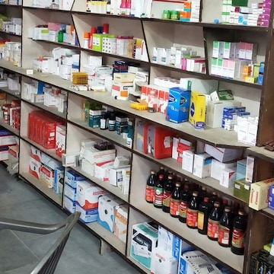

**Figure 5** - Pharmacy

* 1. **GENERAL WARD**

A general ward is a section of a hospital where patients receive inpatient care for various medical conditions. It is typically designed to accommodate multiple patients who require monitoring, treatment, and nursing care but do not require specialized facilities or intensive care. General wards are essential for the efficient management of patient flow in hospitals.

1. **Patient Accommodation**: General wards usually consist of multiple beds arranged in shared rooms or cubicles. This setup allows healthcare providers to monitor and care for several patients at once.
2. **Nursing Care**: Registered nurses and nursing staff are available around the clock to provide care, administer medications, and assist with daily activities for patients.
3. **Basic Medical Equipment**: General wards are equipped with essential medical equipment for monitoring vital signs, administering treatments, and providing comfort to patients. This may include beds, IV stands, wheelchairs, and vital signs monitors.
4. **Multi-disciplinary Care**: Patients in general wards often receive care from a team of healthcare professionals, including doctors, nurses, physical therapists, and pharmacists. This collaborative approach ensures comprehensive care tailored to each patient's needs.
5. **Observation and Monitoring**: While patients in the general ward may not require intensive monitoring, staff regularly check on patients to assess their condition, manage pain, and respond to any changes in their health status.

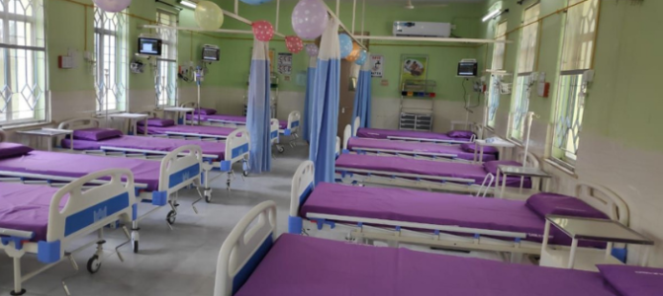

**Figure 6 -** General Ward

* 1. **INJECTTION ROOM**

An injection room is a specialized area within a healthcare facility, such as a hospital or clinic, where patients receive injections or intravenous (IV) medications. This controlled environment is designed to ensure the safe administration of medications while minimizing the risk of infection and complications.

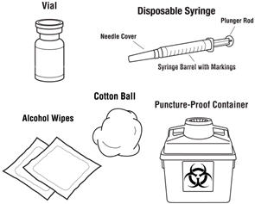

**Figure 7 -** Disposal of used needles

**METHODS OF INJECTIONS**

An injection is a way of administering a liquid to a person using a needle and syringe.

The four most frequently used types of injection are:

* Intravenous (IV) injections. An IV injection is the fastest way to inject a medication and involves using a syringe to inject a medication directly into a vein.
* Intramuscular (IM) injections. IM injections are given deep into a muscle where the medication is then absorbed quickly by surrounding blood vessels.
* Subcutaneous (SC) injections. SC injections are injected into the innermost layer of the skin called the subcutis or hypodermis, which is made up of a network of fat and collagen cells. SC injections are also known as ‘subcut’ or ‘SQ’ injections. These injections work more slowly than an IV or IM injection because the area does not have such a rich blood supply.
* Intradermal (ID) injections. ID injections are given directly into the middle layer of the skin called the dermis. This type of injection is absorbed more slowly again than IV, IM or SC injections.

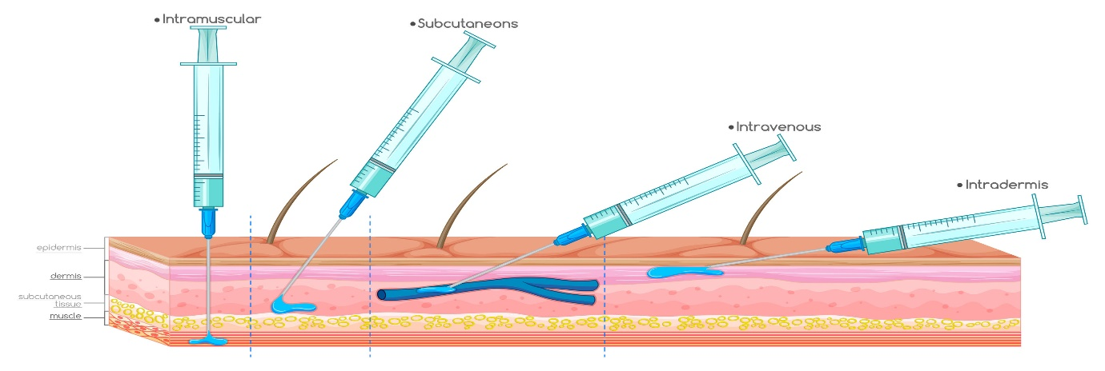

**Figure 8 -** Types of Injections

**Technique of needle use**

Proper needle use is important to perform injections safely, which includes the use of a new, sterile needle for each injection. Needles should not be shared between people, as this increases risk of transmitting blood-borne pathogens. In addition, it is not recommended to reuse a used needle to pierce a medication bag, bottle, or ampule designed to provide multiple doses of a medication, instead a new needle should be used each time the container must be pierced. Aseptic technique should always be practiced when administering injections. This includes the use of barriers including gloves, gowns, and masks for health care providers. It also requires the use of a new, sterile needle, syringe and other equipment for each injection, as well as proper training to avoid touching non-sterile surfaces with sterile items.

**Disposal of used needles**

Used needles should be disposed of in specifically designed sharp containers to reduce the risk of accidental needle sticks and exposure to other people. In addition, a new sharp container should be begun once it is 3⁄4 full. A sharps container which is 3⁄4 filled should be sealed properly to prevent re-opening or accidental opening during transportation.

* 1. **DRESSING**

A dressing is used to protect a wound and prevent infection, but also to allow healing. A dressing should be large enough to totally cover the wound, with a safety margin of about 2.5 cm on all sides beyond the wound. A sterile dressing may be used to control bleeding from a major wound or to absorb any discharge from a minor wound.

A bandage is used in combination with a dressing where a wound is present. A roller bandage is used to secure a dressing in place. A triangular bandage is used as an arm sling or as a pad to control bleeding. It may also be used to support or immobilise an injury to a bone or joint or as improvised padding over a painful injury. A tubular gauze bandage is used to retain a dressing on a finger or toe.

**The seven most commonly used wound dressings-**

1. **Hydrocolloid-** Hydrocolloid dressings are impermeable to bacteria, which is what makes them so effective at preventing infections. They are also long-lasting, biodegradable, and easy to apply.

2. **Hydrogel-** It can be used for a range of wounds that are leaking little or no fluids. Hydrogel can also be used for second-degree burns and infected wounds.

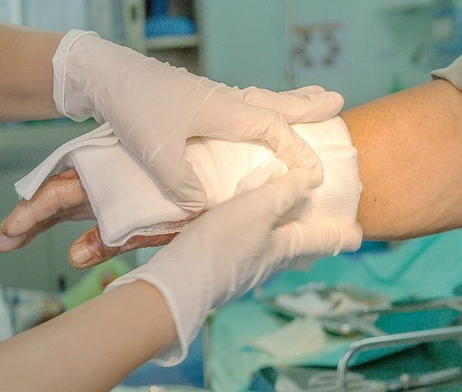

**Figure 9 -** Dressing

3. **Alginate-** These dressings absorb excess liquid and create a gel that helps to heal the wound or burn more quickly. These dressings require changing around every two days, sometimes more, due to the amount of liquid that they absorb and the nature of the wound. Changing them too often could cause too much dryness or could lead to bacteria penetrating the wound. These should only be used for wet wounds with high liquid drainage; else they can hinder healing by drying out wounds too quickly.

4. **Collagen-** Collagen dressings can be used for chronic wounds or stalled wounds, pressure sores, transplant sites, surgical wounds, ulcers, burns, or injuries with a large surface area. Collagen dressings encourage the wound healing process in a range of ways; these include by helping to remove dead tissue, aiding the growth of new blood vessels, and helping to bring the wound edges together, effectively speeding up healing.

5. **Cloth dressings-** These are the most commonly used dressings, often used to protect open wounds or areas of broken skin. They are suitable for minor injuries such as grazes, cuts or areas of delicate skin.These dressings come in all shapes and sizes, from small coverings for fingers to larger ones for wounds across wider areas of the body. As well as pre-cut dressings, these also come in a roll option that is made to be cut to size.

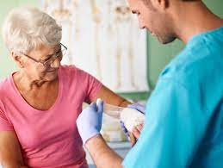

**Figure 10 -** Dressing Technique

1. **HOSPITAL TRAINIG ACTIVITIES**

The consistent, repeated use of good dispensing procedures is vital in ensuring that errors are detected and corrected at all stages of the dispensing process. The term dispensing process covers all activities involved, from receiving the prescription to issuing the prescribed medicine to the patient.

The development and use of written standard operating procedures (SOPs) for the dispensing process will improve consistency and quality of work and can be used for training and reference. The framework for such SOPs may be based on the six major areas of activity:

1. Receive and validate the prescription

2. Understand and interpret the prescription

3. Prepare and label items for issue

4. Make a final check

5. Record the action taken

6. Issue medicine to the patient with clear instructions

and advice

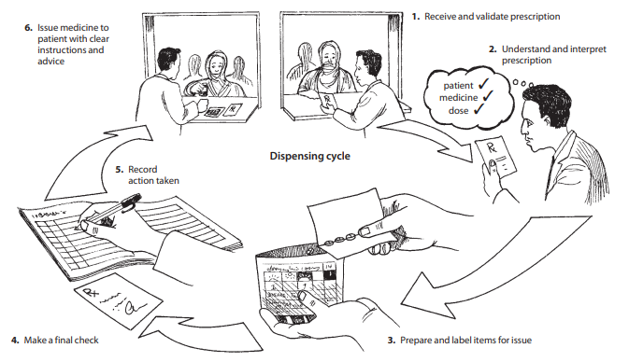

**Figure 11 -** Dispensing Process

**PHYSIOLOGICAL PARAMETERS**

1. pH of Blood:- 7.35-7.45

2. Hemoglobin

a. 13-18gm/dl in adult male

b. 12-16gm/dl in female

c. 9-15gm/dl in children

3. RBC Count (Red Blood Cell)

a. 4.5-5.5 microliter in male

b. 3.5-5.5 microliter in female

4. WBC Count (White Blood Cell) 4000-11000/cu mm

5. Platelet or Thromocytes count 1,50,000-4,00,000

6. Clotting time 2-6 min

7. Bleeding time 2-5 min

8. Blood Sugar Level 80-120mg/100ml

9. Blood cholesterol 150-250mg/100ml

10. Blood urea 8-26 mg/dl

11. Creatinine 1-2mg/dl

12. Sperm count 60-150 million per ml

13. Heart rate 70-80 beats/min

14. Blood pressure 80-120mm /Hg

**WASTE MANAGEMENT IN HOSPITALS**

Inhospitals there are medical waste such as infectious items, chemicals, expired pharmaceuticals, radioactive items, and sharps (used needles, lancets etc.) are hazardous and, if not properly disposed or treated, can be lethal and a threat to the environment.

**Color-Code Containers and Waste Bins**

There are various types of medical wastes which are necessary to be disposed. Every waste from the hospital has separate identification and have different methods for their disposal. Segregating medical wastes based on their type helps ensure that each waste is discarded, transported, and destroyed properly. Waste bin color coding in hospitals help healthcare staff easily segregate waste and identify which waste goes to which container to help and prevent issues arising from random or improper disposal.

Healthcare waste segregation is done ideally at the very first opportunity to avoid hazardous hospital waste from getting mixed with regular waste.

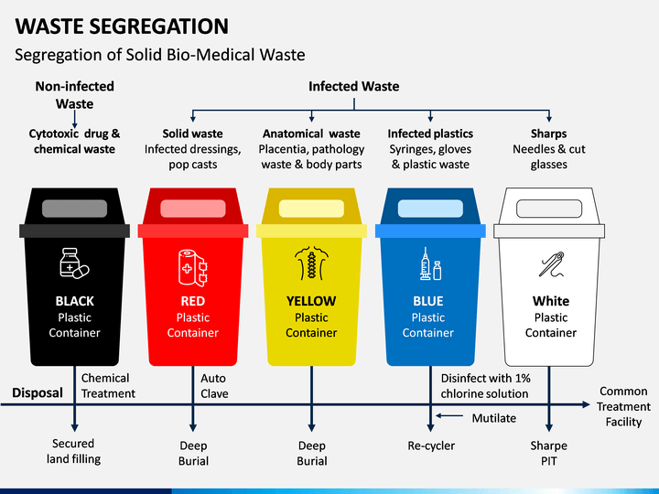

**Figure 12 -** Waste Segregation

These are easy to use and they help get more things done in shorter period of time.

Monitoring checklists also help ensure that people get their daily, weekly, and monthly task done on time.

These are just some of practices that can be done to ensure proper medical waste management in the healthcare facility:

* It minimizes the spread of infectious and reduces the risk of accidental injury to staff, patients, visitors, and the community.
* It reduces the likelihood of contamination of the soil or ground water with chemicals or micro-organisms.
* It attracts fewer insects and rodents and does not attract animals.
* It helps provide an aesthetically pleasing atmosphere.

1. **PROBLEMS ENCOUNTER DURING TRAINING**

**Problems Encountered During Training**

Training in healthcare settings, including areas such as first aid, nursing, or specialized medical procedures, is essential for ensuring that healthcare professionals are competent and confident in their skills. However, several challenges may arise during the training process. Here are some common problems encountered during training:

1. **Limited Resources**:
   * **Insufficient Equipment**: Lack of access to necessary training materials and equipment can hinder practical learning experiences.
   * **Inadequate Training Space**: Crowded or poorly equipped training environments can limit the effectiveness of hands-on practice.
2. **Time Constraints**:
   * **Scheduling Conflicts**: Balancing training with work schedules or other commitments can be challenging, leading to reduced participation or engagement.
   * **Rushed Training Programs**: Limited time for training can result in superficial learning, where participants may not grasp concepts thoroughly.
3. **Diverse Learning Styles**:
   * **Varied Backgrounds**: Trainees may come from different educational backgrounds, making it difficult to address everyone's learning preferences.
   * **Pace of Learning**: Some individuals may require more time to absorb material, while others may progress more quickly, leading to disparities in understanding.
4. **Communication Barriers**:
   * **Language Differences**: Participants with varying levels of proficiency in the training language may struggle to understand instructions or concepts.
   * **Miscommunication**: Inadequate communication between trainers and trainees can lead to confusion or misunderstandings about procedures.
5. **Psychological Barriers**:
   * **Anxiety or Fear**: Trainees may experience anxiety or fear of making mistakes, especially in high-stakes situations like medical training, which can hinder performance.
   * **Lack of Confidence**: New trainees might doubt their abilities, affecting their willingness to participate actively in training exercises.
   * **Outdated Content**: Training programs that do not reflect the latest evidence-based practices may leave trainees ill-prepared for current healthcare challenges.
6. **WORK PROFILE**

I worked in two shifts during my training period. One in day and the other in the night. I worked in the emergency, OPD and dispensing departments one by one to gather knowledge and skills of all of them. I learned social skills along with the working skills to interact nicely with the patients and their guardians. In my working area, I used to be too friendly with the staff and the patients making it easier for me to complete my training in a very excitement way.

**TIME: - 02:00 PM TO 08:00 PM**

1. **CONCLUSION**

The training in a hospital gives us a conclusion that the training in the hospital was really necessary as it now only helped us to see a hospital operates, but it also help me to learn basic function of it like first aid care how to give injection and dispensing of drugs etc.

The conclusion drawn out can be that I have finally learned as to how important role a hospital plays in people lives and that the hospital staff can go to save them since it’s their duty. Since Ram Sagar Combined Hospital receives only 1 rupee per patient, it also shows us their good deed towards mankind and to their service.

1. **REFERENCES**
2. Pharmacy Department- <https://en.m.wikipedia.org/wiki/Pharmacy>
3. Emergency Department- <https://en.wikipedia.org/wiki/Emergency_department>
4. OPD- <https://byjus.com/full-form/opd-full-form>
5. Mehta R.M, "Pharmaceutics-I" IVTH edition Vallabh Prakashan (page no- 269-274).
6. General Ward- <https://en.wikipedia.org/wiki/General_Ward>
7. Dressing department- <https://en.wikipedia.org/wiki/Dressing_(medical)>
8. Phillips H (2006-07-03). "'Rewired brain' revives patient after 19 years". New Scientist.
9. Dispensing- <https://www.bccnm.ca/RN/learning/medication/Pages/dispensing.aspx>
10. Steinson, Blake (2023-08-29). "Compression-Only CPR vs. CPR with Rescue Breaths". Fundamental First Aid Ltd. Retrieved 2023-08-29.
11. Injection- <https://www.medicalnewstoday.com/articles/types-of-injections#side-effects>
12. Male female ward- <https://www.mmh.mw/male-and-female-ward-and-surgical-services/>
13. Services, Department of Health & Human. "Cardiopulmonary resuscitation (CPR)". www.betterhealth.vic.gov.au. Retrieved 2022-10-20.
14. Radiology department- [https://www.sciencedirect.com/topics/nursing-and-health-](https://www.sciencedirect.com/topics/nursing-and-health-professions/radiology-department)
15. Flanders SA, Strasen JH (December 2014). "Review of evidence about family presence during resuscitation". Critical Care Nursing Clinics of North America. 26 (4): 533–50. doi:10.1016/j.ccell.2014.08.010. PMID 25438895
16. Bansal MK, Maraj S, Chewaproug D, Amanullah A (July 2005). "Myocardial contusion injury: redefining the diagnostic algorithm". Emerg Med J. 22 (7): 465–69. doi:10.1136/emj.2004.015339. PMC 1726836. PMID 15983078